P2 Individual Average data- all slopes vary by **subject**, intercept varies by **electrode** (Model 1)

Linear mixed model fit by REML

t-tests use Satterthwaite approximations to degrees of freedom ['lmerMod']

Formula: PeakAmp ~ faceRace * FixArea + (faceRace * FixArea | Subject) + (1 | Electrode)

Data: select

REML criterion at convergence: 6119.2

Scaled residuals:

Min 1Q Median 3Q Max

-3.6339 -0.5316 -0.0086 0.5647 4.4987

Random effects:

Groups Name Variance Std.Dev. Corr

Subject (Intercept) 11.9981 3.4638

faceRaceWhite 1.5066 1.2274 -0.31

FixAreafore 3.2482 1.8023 -0.48 0.24

faceRaceWhite:FixAreafore 2.6025 1.6132 0.19 -0.66 -0.47

Electrode (Intercept) 0.1922 0.4384

Residual 1.0989 1.0483

Number of obs: 1820, groups: Subject, 65; Electrode, 7

Fixed effects:

Estimate Std. Error df t value Pr(>|t|)

(Intercept) 4.7070 0.4631 67.8700 10.164 2.89e-15 ***

faceRaceWhite -1.1251 0.1674 64.0000 -6.723 5.69e-09 ***

FixAreafore -0.7845 0.2341 64.0000 -3.351 0.00135 **

faceRaceWhite:FixAreafore 0.2535 0.2229 64.0000 1.137 0.25966

AIC BIC logLik deviance df.resid

6146.290 6234.395 -3057.145 6114.290 1804.000

P2 Individual Average data- predicted slopes and intercepts for each effect for each subject

$Subject

(Intercept) faceRaceWhite FixAreafore faceRaceWhite:FixAreafore

1 8.3269919 -0.47854555 -3.31609239 -0.025450922

2 3.9325664 -1.82135017 -0.76961048 0.637260546

3 7.5743832 -2.89408491 -1.19737867 1.939438565

4 4.0161392 0.05125309 -1.00934656 0.846775598

5 8.7515631 -1.09207137 -0.77702822 -0.043629514

6 4.5892213 -1.14699711 -1.60898305 0.294519573

7 2.9741604 -1.84418959 0.89977753 -0.868254033

8 0.1408061 0.50146614 0.41894709 -1.253774411

9 6.2370828 -1.87139128 -1.48565656 1.204482692

10 5.7249241 -1.61093516 1.26698169 -0.007214193

11 7.1224683 -3.06659624 -2.05969595 1.407706418

12 7.5387959 -0.89652858 0.46730802 -0.521939328

13 3.0524351 -0.34066152 -2.03186950 1.708404900

14 0.4602186 -1.29886973 0.20278306 2.240827567

15 7.2007666 -2.17046940 -3.32193269 2.283157240

16 8.9143415 -1.10266152 -1.58870309 1.324091171

17 4.0636540 0.55151585 -0.51677560 -2.510958423

18 9.8049705 -4.07245807 -0.53110828 0.584097567

19 5.9073079 -0.39452280 -1.00444263 -0.046376225

20 1.3998515 -0.63022641 -0.36640928 -0.655590819

21 1.9615362 -0.41481847 -0.06012147 0.381086304

22 -0.7866473 0.52186452 1.12988345 -0.653300591

23 8.5361901 -0.63342461 -2.48776577 0.064215666

24 8.0447515 -0.72817451 -1.13221680 -1.102265603

25 0.9072729 -1.80957918 -3.64028942 2.015439562

26 -1.4249710 -1.58187938 0.84884177 0.455746755

27 4.1376386 -0.32243274 2.81232844 -0.471262883

28 5.7127429 -0.48615175 -2.25898188 0.167104666

29 -0.4225565 -0.74978952 -0.44019592 -0.141879988

30 11.4555086 -0.55774400 -1.68481758 -0.667872235

31 7.9627978 -0.09882472 -3.19653066 -0.771468526

32 9.2807802 -2.40404993 -3.00664115 1.747592537

33 7.6378578 -1.42768622 -3.33406570 2.434455383

$Electrode

(Intercept) faceRaceWhite FixAreafore faceRaceWhite:FixAreafore

C3 4.793914 -1.12513 -0.7845187 0.2535374

C4 4.272797 -1.12513 -0.7845187 0.2535374

CP3 4.465486 -1.12513 -0.7845187 0.2535374

CP4 4.153006 -1.12513 -0.7845187 0.2535374

CPZ 5.118278 -1.12513 -0.7845187 0.2535374

CZ 5.328006 -1.12513 -0.7845187 0.2535374

PZ 4.817659 -1.12513 -0.7845187 0.2535374

P2 Trial by trial data- all slopes vary by **subject**, intercept varies by **electrode** (Model 1)

Linear mixed model fit by REML

t-tests use Satterthwaite approximations to degrees of freedom ['lmerMod']

Formula: PeakAmp ~ Race * Fix + (Race * Fix | Subject) + (1 | Electrode)

Data: dat

REML criterion at convergence: 1431572

Scaled residuals:

Min 1Q Median 3Q Max

-5.7264 -0.6478 -0.0257 0.6200 6.3802

Random effects:

Groups Name Variance Std.Dev. Corr

Subject (Intercept) 11.1142 3.334

RaceWhite 1.1782 1.085 -0.13

Fixforehead 2.3802 1.543 -0.39 0.29

RaceWhite:Fixforehead 2.3429 1.531 0.12 -0.61 -0.53

Electrode (Intercept) 0.2652 0.515

Residual 86.1050 9.279

Number of obs: 196168, groups: Subject, 65; Electrode, 7

Fixed effects:

Estimate Std. Error df t value Pr(>|t|)

(Intercept) 9.0189 0.4590 62.4400 19.650 < 2e-16 ***

RaceWhite -0.9028 0.1473 62.5500 -6.130 6.51e-08 ***

Fixforehead -0.4167 0.2005 64.2800 -2.079 0.0416 *

RaceWhite:Fixforehead 0.1301 0.2079 63.6500 0.626 0.5335

AIC BIC logLik deviance df.resid

1431598.2 1431761.2 -715783.1 1431566.2 196152.0 P2 Trial by trial data- predicted slopes and intercepts for each effect for each subject

$Subject

(Intercept) RaceWhite Fixforehead RaceWhite:Fixforehead

1 13.140682 -0.43139180 -1.64630886 0.019356915

2 9.370505 -1.01528231 -0.31634704 0.346515584

3 11.431828 -1.85478773 -1.03725110 1.284433778

4 10.352642 -0.15422281 -0.76985338 1.225991285

5 10.552654 -0.94077569 -0.34079818 -0.265624478

6 8.749355 -0.97973712 -0.81637408 0.414915063

7 9.815448 -0.96355915 -0.59498009 1.443070024

8 3.758054 0.79339883 1.03428024 -1.506189111

9 9.376405 -1.12315083 -1.52491516 0.836802232

10 10.294554 -0.77454801 1.89263352 -0.289731385

11 8.957067 -2.64902533 -1.38370115 1.563226744

12 10.940476 -0.06353217 0.37501118 -0.635909677

13 5.675623 0.03200054 -1.79801007 1.500922861

14 3.962413 -0.84371892 0.55214365 1.500437054

15 10.131672 -2.05393338 -2.41932253 1.939578922

16 13.173831 -0.93376763 -0.82107696 2.249054140

17 10.972335 0.84013655 0.19465844 -2.254237157

18 11.904079 -4.10593986 -0.06587264 0.350032064

19 14.313505 -0.92690934 -0.24428809 0.003681717

20 4.757957 -0.56881146 0.04315171 -0.378970717

21 7.037753 0.09598303 -0.19974764 0.465122212

22 5.922102 0.96840612 1.38327234 -1.155387855

23 14.318240 0.15615297 -1.98883634 0.416411978

24 12.152228 -0.61113445 -0.97590403 -1.146755274

25 4.173897 -1.58914579 -2.60831107 0.468447078

26 3.172811 -0.79825114 1.79921904 -1.059539273

27 6.617410 -0.04864320 3.07421619 -1.061759272

28 8.577770 -0.89850127 -1.65620592 0.460292739

29 5.141741 -0.42286460 -0.27452769 -0.632042956

30 13.958025 -0.50408023 -1.40508240 -0.068364298

31 11.602661 -0.41424712 -2.69532895 -0.261010151

32 11.454771 -1.26154129 -1.93398190 0.281580291

33 10.701645 -1.31821803 -2.82967363 2.908505387

$Electrode

(Intercept) RaceWhite Fixforehead RaceWhite:Fixforehead

C3 8.899289 -0.9028307 -0.4167475 0.1301422

C4 8.284278 -0.9028307 -0.4167475 0.1301422

CP3 8.770967 -0.9028307 -0.4167475 0.1301422

CP4 8.613568 -0.9028307 -0.4167475 0.1301422

CPZ 9.665777 -0.9028307 -0.4167475 0.1301422

CZ 9.403054 -0.9028307 -0.4167475 0.1301422

PZ 9.495637 -0.9028307 -0.4167475 0.1301422

P2 Trial by trial data- all slopes vary by **subject**, intercept varies by **electrode** and **trial** (Model 3)

Linear mixed model fit by REML

t-tests use Satterthwaite approximations to degrees of freedom ['lmerMod']

Formula: PeakAmp ~ Race * Fix + (Race * Fix | Subject) + (1 | Electrode) + (1 | Trial)

Data: dat

REML criterion at convergence: 1429357

Scaled residuals:

Min 1Q Median 3Q Max

-5.7148 -0.6469 -0.0246 0.6203 6.3626

Random effects:

Groups Name Variance Std.Dev. Corr

Trial (Intercept) 1.4256 1.194

Subject (Intercept) 11.1630 3.341

RaceWhite 1.1657 1.080 -0.15

Fixforehead 2.3033 1.518 -0.41 0.27

RaceWhite:Fixforehead 2.3581 1.536 0.15 -0.59 -0.52

Electrode (Intercept) 0.2653 0.515

Residual 84.6939 9.203

Number of obs: 196168, groups: Trial, 512; Subject, 65; Electrode, 7

Fixed effects:

Estimate Std. Error df t value Pr(>|t|)

(Intercept) 9.0426 0.4628 64.1600 19.538 < 2e-16 ***

RaceWhite -0.9144 0.1466 62.4400 -6.236 4.33e-08 ***

Fixforehead -0.4494 0.1975 64.2500 -2.275 0.0262 *

RaceWhite:Fixforehead 0.1857 0.2084 63.5100 0.891 0.3763

AIC BIC logLik deviance df.resid

1429385.5 1429558.7 -714675.8 1429351.5 196151.0

P2 Trial by trial data- all slopes vary by **subject** and **trial**, intercept varies by **electrode** (Model 4.2)

Linear mixed model fit by REML

t-tests use Satterthwaite approximations to degrees of freedom ['lmerMod']

Formula: PeakAmp ~ Race * Fix + (Race * Fix | Subject) + (1 | Electrode) + (Race * Fix | Trial)

Data: dat

REML criterion at convergence: 1424430

Scaled residuals:

Min 1Q Median 3Q Max

-5.7277 -0.6464 -0.0207 0.6220 6.3967

Random effects:

Groups Name Variance Std.Dev. Corr

Trial (Intercept) 4.8607 2.2047

RaceWhite 9.3543 3.0585 -0.69

Fixforehead 8.5074 2.9167 -0.67 0.47

RaceWhite:Fixforehead 18.8317 4.3395 0.48 -0.70 -0.69

Subject (Intercept) 11.2195 3.3496

RaceWhite 1.2527 1.1192 -0.16

Fixforehead 2.3706 1.5397 -0.39 0.29

RaceWhite:Fixforehead 2.5866 1.6083 0.15 -0.60 -0.54

Electrode (Intercept) 0.2654 0.5152

Residual 81.4013 9.0223

Number of obs: 196168, groups: Trial, 512; Subject, 65; Electrode, 7

Fixed effects:

Estimate Std. Error df t value Pr(>|t|)

(Intercept) 9.0723 0.4710 68.3200 19.264 < 2e-16 ***

RaceWhite -0.9285 0.2028 183.1800 -4.579 8.6e-06 ***

Fixforehead -0.4841 0.2380 124.7400 -2.034 0.0441 *

RaceWhite:Fixforehead 0.2103 0.2894 183.0200 0.727 0.4684

AIC BIC logLik deviance df.resid

1399672.8 1399937.6 -699810.4 1399620.8 196142.0 P2 Trial by trial data- BLUPs for trial (predicted intercept, slope for Race and Fix for each trial)

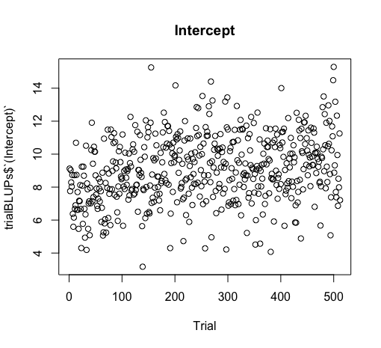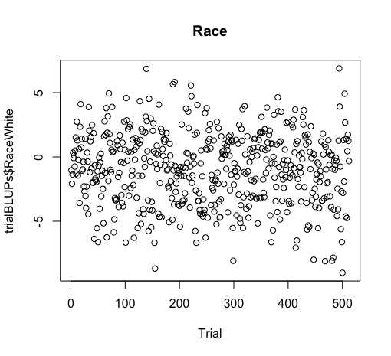 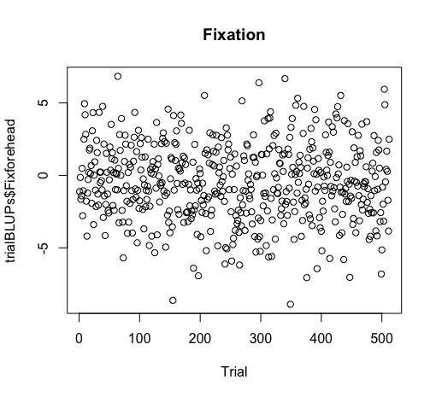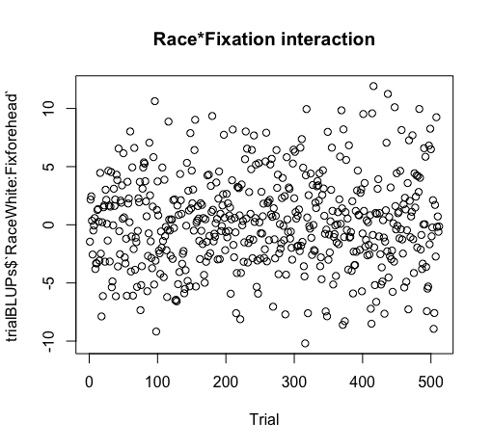

P2 Trial by trial data- all slopes vary by **subject**, intercept varies by **electrode,** fixed effect of **trial and interactions** (Model 5.2)

Linear mixed model fit by REML

t-tests use Satterthwaite approximations to degrees of freedom ['lmerMod']

Formula: PeakAmp ~ Race * Fix * Trial + (Race * Fix | Subject) + (1 | Electrode)

Data: dat

REML criterion at convergence: 1431119

Scaled residuals:

Min 1Q Median 3Q Max

-5.7307 -0.6470 -0.0256 0.6213 6.3829

Random effects:

Groups Name Variance Std.Dev. Corr

Subject (Intercept) 11.1173 3.334

RaceWhite 1.1689 1.081 -0.13

Fixforehead 2.3631 1.537 -0.39 0.29

RaceWhite:Fixforehead 2.3423 1.530 0.12 -0.61 -0.52

Electrode (Intercept) 0.2652 0.515

Residual 85.8828 9.267

Number of obs: 196168, groups: Subject, 65; Electrode, 7

Fixed effects:

Estimate Std. Error df t value Pr(>|t|)

(Intercept) 7.944e+00 4.647e-01 6.600e+01 17.097 < 2e-16 ***

RaceWhite -4.742e-01 1.785e-01 1.370e+02 -2.656 0.00884 **

Fixforehead -1.175e-01 2.243e-01 1.020e+02 -0.524 0.60147

Trial 4.270e-03 2.866e-04 1.959e+05 14.897 < 2e-16 ***

RaceWhite:Fixforehead -2.086e-01 2.526e-01 1.390e+02 -0.826 0.41019

RaceWhite:Trial -1.710e-03 4.032e-04 1.957e+05 -4.241 2.22e-05 ***

Fixforehead:Trial -1.193e-03 4.048e-04 1.959e+05 -2.948 0.00320 **

RaceWhite:Fixforehead:Trial 1.376e-03 5.705e-04 1.958e+05 2.412 0.01586 *

P2 Binned data- all slopes vary by **subject**, intercept varies by **electrode** (Model 1)

Linear mixed model fit by REML

t-tests use Satterthwaite approximations to degrees of freedom ['lmerMod']

Formula: PeakAmp ~ Race * Fix + (Race * Fix | Subject) + (1 | Electrode)

Data: binDat

REML criterion at convergence: 127004.7

Scaled residuals:

Min 1Q Median 3Q Max

-5.0045 -0.6476 -0.0230 0.6307 4.0968

Random effects:

Groups Name Variance Std.Dev. Corr

Subject (Intercept) 10.4744 3.236

RaceWhite 1.4486 1.204 -0.25

Fixforehead 2.7765 1.666 -0.42 0.29

RaceWhite:Fixforehead 2.6356 1.623 0.12 -0.62 -0.51

Electrode (Intercept) 0.1824 0.427

Residual 11.9406 3.456

Number of obs: 23730, groups: Subject, 65; Electrode, 7

Fixed effects:

Estimate Std. Error df t value Pr(>|t|)

(Intercept) 5.5740 0.4350 67.1300 12.813 < 2e-16 ***

RaceWhite -1.0203 0.1624 61.7700 -6.282 3.73e-08 ***

Fixforehead -0.6739 0.2164 64.1100 -3.115 0.00275 **

RaceWhite:Fixforehead 0.2143 0.2208 62.7600 0.970 0.33560

AIC BIC logLik deviance df.resid

127031.58 127160.77 -63499.79 126999.58 23714.00 P2 Binned data- predicted slopes and intercepts for each effect for each subject

$Subject

(Intercept) RaceWhite Fixforehead RaceWhite:Fixforehead

1 8.7235699 -0.24455547 -2.168510601 -0.316936701

2 4.6756555 -1.02756988 -0.227580173 -0.434243435

3 8.4216397 -2.35452753 -1.293295646 1.425857003

4 5.7767193 -0.52867363 -0.750894159 0.787114355

5 8.7032334 -0.91538790 -0.488209709 -0.297623552

6 5.4498464 -0.98848612 -1.071469665 0.233115071

7 5.1603517 -0.15459875 -1.432379115 1.516217431

8 0.7977289 0.96516854 0.698052565 -1.671707145

9 6.9567474 -1.28199190 -1.272913363 0.351718320

10 6.5869055 -1.46604758 1.550633491 -0.153309463

11 7.4538018 -3.05171933 -1.896754433 1.371880534

12 7.9519636 -0.71768186 0.802381766 -0.775297328

13 3.3187205 -0.05514162 -2.095892777 1.669203526

14 1.2359741 -1.30802813 -0.005849225 2.259539841

15 7.4830079 -1.96409018 -2.835742747 2.142693460

16 9.4996358 -1.17384517 -1.521158683 1.517579300

17 4.9018518 1.16519572 0.597450156 -2.793535419

18 9.8671256 -3.91898805 0.029369852 0.330651872

19 8.3927022 -0.56205175 -0.697325801 -0.043750932

20 1.8857383 -0.67637073 0.025246759 -0.985134866

21 3.2319670 0.03377236 -0.237813754 0.735628086

22 0.8635180 0.96895177 1.995089873 -1.356643120

23 9.6422599 -0.53850178 -1.858203046 0.256811819

24 8.7577361 -0.77521242 -1.196141696 -0.642842904

25 1.3586567 -1.45263750 -3.538282232 1.314568975

26 -0.1044031 -1.58710140 0.784794250 0.310609523

27 4.6338854 -0.31391015 2.685411937 -0.248158039

28 6.0224565 -0.41559598 -2.000873003 0.455709300

29 0.5598324 -0.76706970 -0.431970081 -0.039212980

30 11.9190699 -0.57406610 -1.729768232 -0.478282699

31 8.3707761 0.21868925 -3.146619787 -0.318584722

32 9.5252943 -2.36922737 -2.883440139 1.857761349

33 8.0255048 -1.04381047 -3.054301778 2.225516272

$Electrode

(Intercept) RaceWhite Fixforehead RaceWhite:Fixforehead

C3 5.581363 -1.020329 -0.6739239 0.2142994

C4 5.050600 -1.020329 -0.6739239 0.2142994

CP3 5.358335 -1.020329 -0.6739239 0.2142994

CP4 5.094820 -1.020329 -0.6739239 0.2142994

CPZ 6.028402 -1.020329 -0.6739239 0.2142994

CZ 6.076211 -1.020329 -0.6739239 0.2142994

PZ 5.828094 -1.020329 -0.6739239 0.2142994P2 Binned data- all slopes vary by **subject**, intercept varies by **electrode** and **bin** (Model 2)

Linear mixed model fit by REML

t-tests use Satterthwaite approximations to degrees of freedom ['lmerMod']

Formula: PeakAmp ~ Race * Fix + (Race * Fix | Subject) + (1 | Electrode) + (1 | Bin)

Data: binDat

REML criterion at convergence: 126803.2

Scaled residuals:

Min 1Q Median 3Q Max

-5.0722 -0.6455 -0.0231 0.6339 4.0817

Random effects:

Groups Name Variance Std.Dev. Corr

Subject (Intercept) 10.4514 3.2329

RaceWhite 1.4529 1.2054 -0.25

Fixforehead 2.7636 1.6624 -0.42 0.28

RaceWhite:Fixforehead 2.6379 1.6242 0.12 -0.62 -0.51

Bin (Intercept) 0.1223 0.3497

Electrode (Intercept) 0.1824 0.4271

Residual 11.8190 3.4379

Number of obs: 23730, groups: Subject, 65; Bin, 15; Electrode, 7

Fixed effects:

Estimate Std. Error df t value Pr(>|t|)

(Intercept) 5.5901 0.4440 72.3900 12.591 <2e-16 ***

RaceWhite -1.0179 0.1625 61.8100 -6.265 4e-08 ***

Fixforehead -0.6709 0.2158 64.1400 -3.109 0.0028 **

RaceWhite:Fixforehead 0.2145 0.2207 62.7700 0.972 0.3349

AIC BIC logLik deviance df.resid

126832.09 126969.36 -63399.05 126798.09 23713.00 P2 Binned data- BLUPs for trial (predicted intercept for each trial)

$Bin

(Intercept) RaceWhite Fixforehead RaceWhite:Fixforehead

1 4.975229 -1.017924 -0.6708838 0.2145205

2 4.756715 -1.017924 -0.6708838 0.2145205

3 5.338938 -1.017924 -0.6708838 0.2145205

4 5.566242 -1.017924 -0.6708838 0.2145205

5 5.854004 -1.017924 -0.6708838 0.2145205

6 5.729003 -1.017924 -0.6708838 0.2145205

7 5.761014 -1.017924 -0.6708838 0.2145205

8 5.796182 -1.017924 -0.6708838 0.2145205

9 5.633260 -1.017924 -0.6708838 0.2145205

10 5.614235 -1.017924 -0.6708838 0.2145205

11 5.908639 -1.017924 -0.6708838 0.2145205

12 5.716380 -1.017924 -0.6708838 0.2145205

13 5.848772 -1.017924 -0.6708838 0.2145205

14 5.896463 -1.017924 -0.6708838 0.2145205

15 5.456276 -1.017924 -0.6708838 0.2145205

P2 Binned data- all slopes vary by **subject** and **bin**, intercept varies by **electrode** (Model 4.1)

Linear mixed model fit by REML

t-tests use Satterthwaite approximations to degrees of freedom ['lmerMod']

Formula: PeakAmp ~ Race * Fix + (Race * Fix | Subject) + (1 | Electrode) + (Race * Fix | Bin)

Data: binDat

REML criterion at convergence: 126668.9

Scaled residuals:

Min 1Q Median 3Q Max

-4.9841 -0.6456 -0.0238 0.6302 4.1008

Random effects:

Groups Name Variance Std.Dev. Corr

Subject (Intercept) 10.4368 3.2306

RaceWhite 1.4594 1.2081 -0.25

Fixforehead 2.7717 1.6648 -0.42 0.29

RaceWhite:Fixforehead 2.6483 1.6274 0.12 -0.63 -0.51

Bin (Intercept) 0.3364 0.5800

RaceWhite 0.3640 0.6033 -0.69

Fixforehead 0.2383 0.4881 -0.80 0.51

RaceWhite:Fixforehead 0.8320 0.9121 0.63 -0.80 -0.70

Electrode (Intercept) 0.1824 0.4271

Residual 11.7174 3.4231

Number of obs: 23730, groups: Subject, 65; Bin, 15; Electrode, 7

Fixed effects:

Estimate Std. Error df t value Pr(>|t|)

(Intercept) 5.5902 0.4598 77.8900 12.158 < 2e-16 ***

RaceWhite -1.0445 0.2265 34.1700 -4.612 5.38e-05 ***

Fixforehead -0.6696 0.2509 62.4600 -2.669 0.00969 **

RaceWhite:Fixforehead 0.2453 0.3248 30.5400 0.755 0.45587

AIC BIC logLik deviance df.resid

126717.22 126927.16 -63332.61 126665.22 23704.00

P2 Binned data- BLUPs for trial (predicted intercepts and slopes for Race and Fix for each trial)

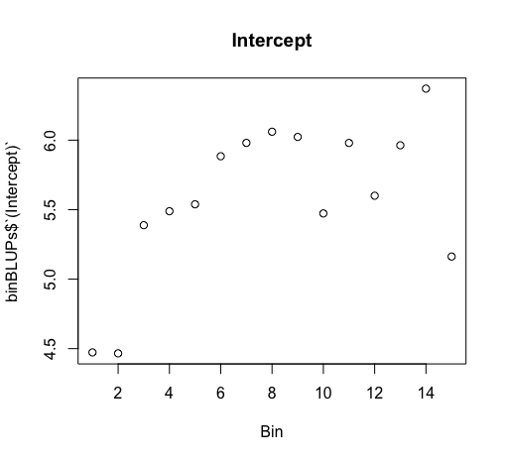 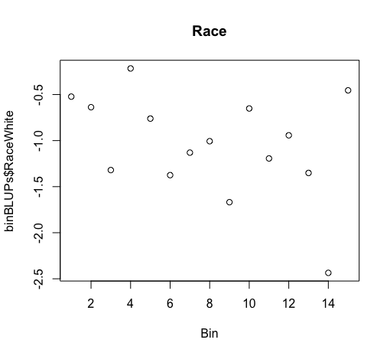 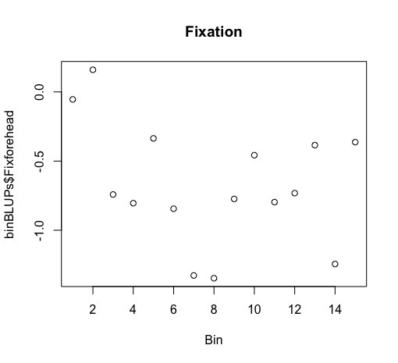 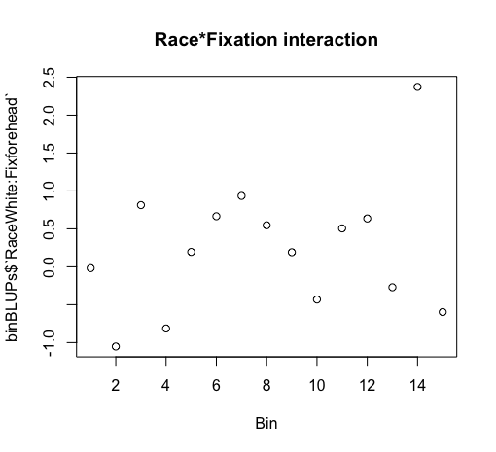

P2 Binned data- all slopes vary by **subject**, intercept varies by **electrode,** add fixed effect of **bin and interactions** (Model 5.1)

Linear mixed model fit by REML

t-tests use Satterthwaite approximations to degrees of freedom ['lmerMod']

Formula: PeakAmp ~ Race * Fix * Bin + (Race * Fix | Subject) + (1 | Electrode)

Data: binDat

REML criterion at convergence: 126889.4

Scaled residuals:

Min 1Q Median 3Q Max

-5.0885 -0.6425 -0.0232 0.6314 4.1437

Random effects:

Groups Name Variance Std.Dev. Corr

Subject (Intercept) 10.4462 3.2321

RaceWhite 1.4660 1.2108 -0.25

Fixforehead 2.7708 1.6646 -0.42 0.29

RaceWhite:Fixforehead 2.6453 1.6264 0.12 -0.63 -0.51

Electrode (Intercept) 0.1824 0.4271

Residual 11.8699 3.4453

Number of obs: 23730, groups: Subject, 65; Electrode, 7

Fixed effects:

Estimate Std. Error df t value Pr(>|t|)

(Intercept) 4.845e+00 4.421e-01 7.200e+01 10.961 < 2e-16 ***

RaceWhite -5.630e-01 1.997e-01 1.380e+02 -2.819 0.00552 **

Fixforehead -3.671e-01 2.447e-01 1.050e+02 -1.500 0.13660

Bin 1.033e-01 1.153e-02 2.350e+04 8.959 < 2e-16 ***

RaceWhite:Fixforehead -2.361e-01 2.745e-01 1.490e+02 -0.860 0.39113

RaceWhite:Bin -6.459e-02 1.633e-02 2.338e+04 -3.957 7.62e-05 ***

Fixforehead:Bin -4.358e-02 1.624e-02 2.347e+04 -2.684 0.00729 **

RaceWhite:Fixforehead:Bin 6.456e-02 2.310e-02 2.332e+04 2.794 0.00520 **